Ryan Neumann

Artificial Intelligence

Problem 1.4

(b) It took the perceptron 11 iterations before it successfully converged. The hypothesis is close to the target function. 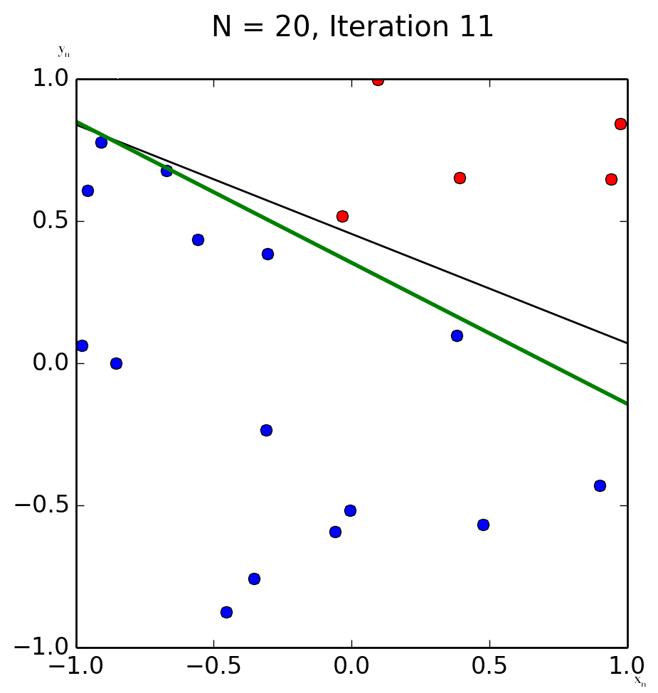

(c) The second randomly generated set of 20 only took 3 iterations to complete. I would say the first set’s hypothesis was closer to the target function, however, you also need to take into consideration that this data set has a much bigger gap between classes.

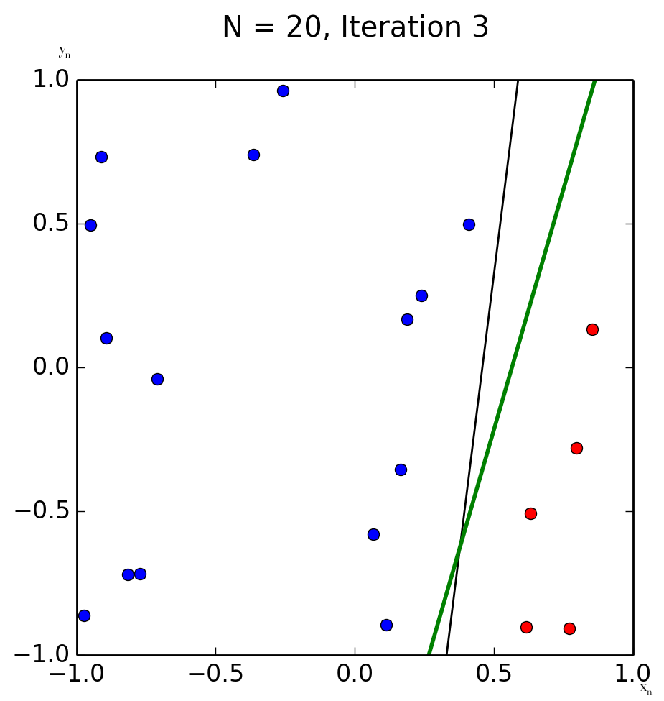

(d) On the data set of size 100, it took 70 iterations to converge. The hypothesis is starting to get closer to the target function. The larger the amount of data, the longer the perceptron takes, however, it gives a more accurate guess the more data it has to read.

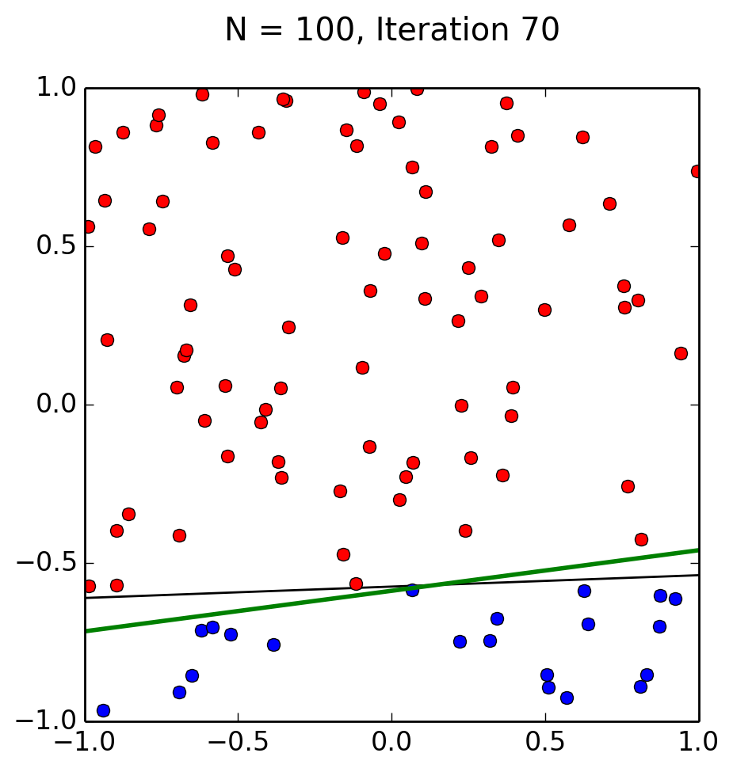

(e) The data set of size 1000 took a total of 505 different iterations before coming to it’s conclusion. However, the hypothesis is lined up perfectly with the target function.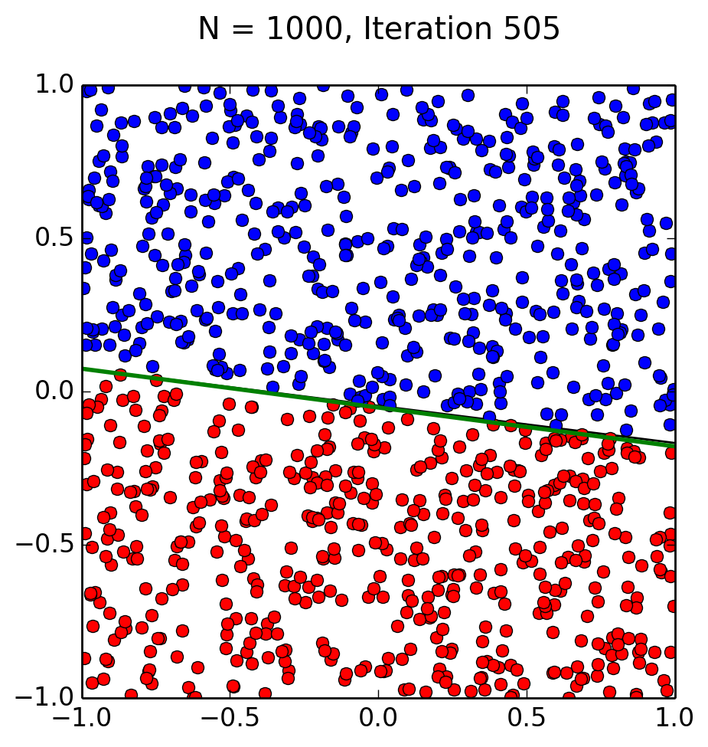

(f) The algorithm took 2788 iterations before it was finally complete.

(g)

(h) As N increased, which was the size of the data the perceptron was given to read, as did the time it took to converge. Also as N increased, so did the accuracy. The more data the perceptron has to work with, the more precise the hypothesis will be to the target function. So using N as the size of the data set, and d as the duration of time that it takes for the perceptron to complete - As N increases, so does d. The same can be applied to as N decreases, so does the duration, or d, of time that the perceptron takes to converge.